OOPS:

Ibit questions

What is OOPS??
OOPS stands for Object-Oriented Programming System.
OOPS essentially means a system of programming where the primary focus is on objects, which allows for better organization, modularity, and reusability of code.
By using OOPS we can take advantage of inheritance, encapsulation, abstraction,. polymorphism

Drive file:
https://drive.google.com/drive/folders/1ZrVWAc-hb_loI3G0px4lK3-spRLBBoQe

Class:
Human being is a class, in which body parts are member variables and actions performed by them are methods.
Objects are people.

Inheritance:

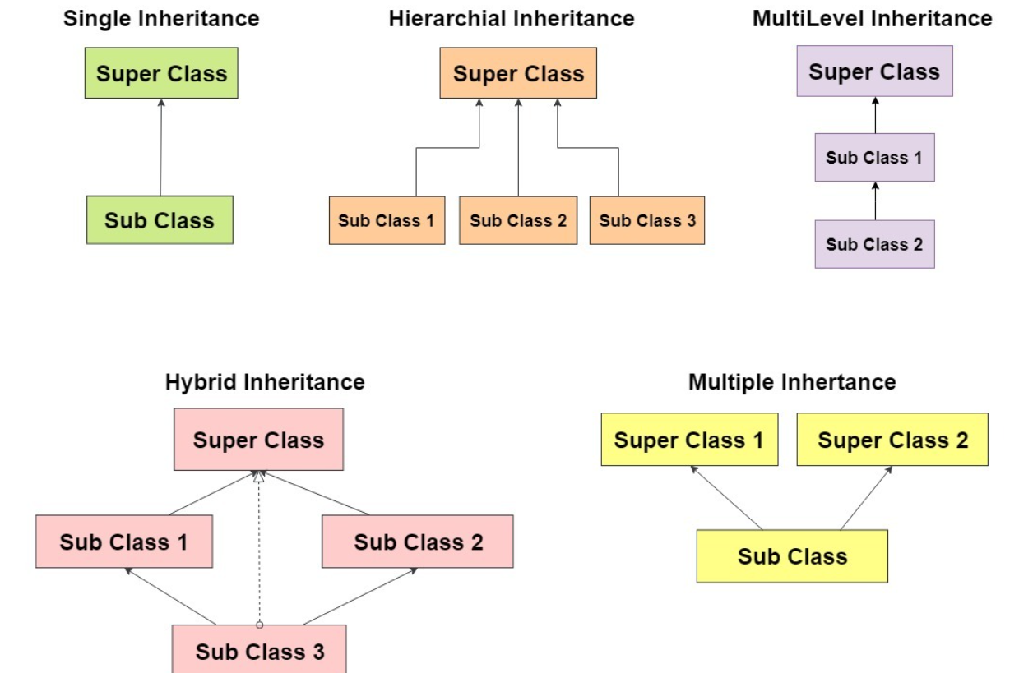

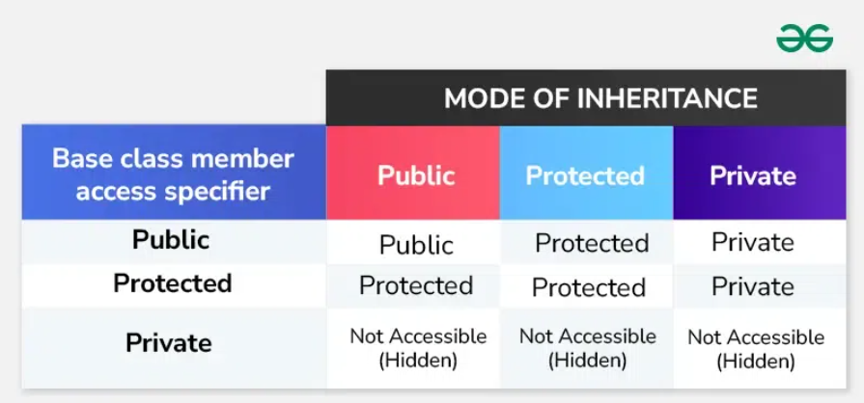
Private variables cannot be inherited

Diamond problem in C++:

class Base {
public:
Base() { cout << "Base constructor" << endl; }
void display() { cout << "display Base class" << endl; }
};

class Derived1 : public Base {
public:
Derived1() { cout << "Derived1 constructor" << endl; }
};

class Derived2 : public Base {
public:
Derived2() { cout << "Derived2 constructor" << endl; }
};

class Final : public Derived1, public Derived2 {
public:
Final() { cout << "Final constructor" << endl; }
};

int main() {
Final obj;
obj.display(); // Calls Base::display()
return 0;
}
Output : compilation error

Diamond problem:
The Final class inherits from both Derived1 and Derived2. Since both of these classes inherit from Base, two copies of the Base class are created within the Final object:
- Derived1 has its own copy of Base.
- Derived2 has its own copy of Base.
This causes ambiguity when calling obj.display(). The compiler doesn't know whether to call obj.Derived1::display() or obj.Derived2::display(). As a result, the code doesn't compile and gives a compilation error due to ambiguity.
Base
/ \
/ \
Der1 Der2
\ /
\ /
Final
Diamond shape

Solution: Virtual Inheritance
This means that Derived1 and Derived2 do not create their own separate instances of Base. Instead, they share a single, common instance of Base.
When virtual is used, both Derived1 and Derived2 contain a pointer (or a reference) to a shared instance of Base instead of having their own separate instances.

class Base {
public:
Base() { cout << "Base constructor" << endl; }
void display() { cout << "display Base class" << endl; }
};

class Derived1 : virtual public Base {
public:
Derived1() { cout << "Derived1 constructor" << endl; }
};

class Derived2 : virtual public Base {
public:
Derived2() { cout << "Derived2 constructor" << endl; }
};

class Final : public Derived1, public Derived2 {
public:
Final() { cout << "Final constructor" << endl; }
};

int main() {
Final obj;
obj.display(); // Calls Base::display()
return 0;
}

Output:
Base constructor
Derived1 constructor
Derived2 constructor
Final constructor
display Base class

Problem in Multiple inheritance:
The below is not exactly the diamond problem But there is an ambiguity
when you try to call obj.display() in the main() function because the compiler does not know whether to call Derived1::display() or Derived2::display().

class Derived1 {
public:
void display() { cout << "display Derived1" << endl; }
Derived1() { cout << "Derived1 constructor" << endl; }
};

class Derived2 {
public:
void display() { cout << "display Derived2" << endl; }
Derived2() { cout << "Derived2 constructor" << endl; }
};

class Final : public Derived1, public Derived2 {
public:
Final() { cout << "Final constructor" << endl; }
};

int main() {
Final obj;
obj.display(); // Calls Base::display()
return 0;
}

Solution1: Resolve Ambiguity by Specifying the Class
class Derived1 {
public:
void display() { cout << "display Derived1" << endl; }
Derived1() { cout << "Derived1 constructor" << endl; }
};

class Derived2 {
public:
void display() { cout << "display Derived2" << endl; }
Derived2() { cout << "Derived2 constructor" << endl; }
};

class Final : public Derived1, public Derived2 {
public:
Final() { cout << "Final constructor" << endl; }
};

int main() {
Final obj;
obj.Derived1::display(); // Calls Derived1::display()
obj.Derived2::display(); // Calls Derived2::display()
}
Output:
Derived1 constructor
Derived2 constructor
Final constructor
display Derived1
display Derived2

Solution2: Override the display() Method in Final

class Derived1 {
public:
Derived1() { cout << "Derived1 constructor" << endl; }
void display() { cout << "display Derived1" << endl; }
};

class Derived2 {
public:
void display() { cout << "display Derived2" << endl; }
Derived2() { cout << "Derived2 constructor" << endl; }
};

class Final : public Derived1, public Derived2 {
public:
Final() { cout << "Final constructor" << endl; }
void display() { cout << "display Final" << endl; }
};

int main() {
Final obj;
obj.display(); // Calls Final::display()
return 0;
}
Output:
Derived1 constructor
Derived2 constructor
Final constructor
display Final

In-fact in java, multiple inheritance of classes itself is not allowed becoz of this problem…Lets move on to java for some time;

Becoz of the above problem, multiple inheritance of classes is not allowed. So interfaces are introduced to solve multiple inheritance problem
Interfaces:
Classes that have only abstract methods(pure virtual functions). It cannot have a method body.
Abstract classes:
Class that can have both abstract methods and non abstract methods
Classes:
No abstract classes are allowed.

There are two ways to achieve abstraction in java
- Abstract class (0 to 100%)
- Interface (100%)

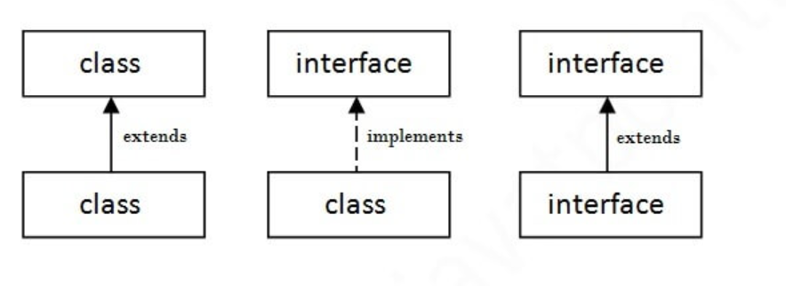

There are mainly three reasons to use interface. They are given below.
- It is used to achieve abstraction.
- By interface, we can support the functionality of multiple inheritance.
- It can be used to achieve loose coupling. (car engine example)

Multiple inheritance in Java by interface:
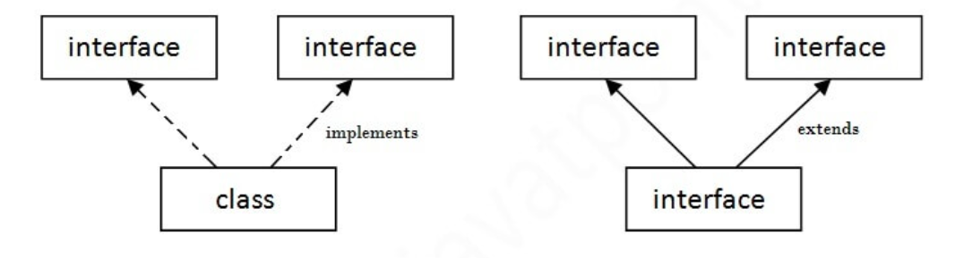
It is possible in interface because there is no definition of functions WRT base classes
We will define them in the derived class. So compiler will have a clear idea which method to invoke

- interface Printable{
- void print();
- }
- interface Showable{
- void print();
- }

- class TestInterface3 implements Printable, Showable{
- public void print(){System.out.println("Hello");}
- public static void main(String args[]){
- TestInterface3 obj = new TestInterface3();
- obj.print();
- }
- }
Output : Hello

Encapsulation:
Encapsulation is a process or technique that bundles the data(member variables) and behavior(methods) together in a single unit.
Every class is an example of encapsulation.
Why should we bundle member variables and methods?
Because there may be sensitive member variables in our class which can’t be accessed directly outside the class, we can access them indirectly if we know which method to be called and what parameters to send for the method in order to access them.
It helps in data hiding i.e the data that has to be hided was declared as private so that it can not be directly accessed from outside class. To access them indirectly, public getter and setter methods are created inside the class.
Thus we can achieve security with the help of data hiding.

Real life examples:
Lets say balance variable of our bank account.
If balance variable is declared as a public anyone can access it.
So it is declared as private and only accessed using check_balance( ) with appropriate account details as parameters

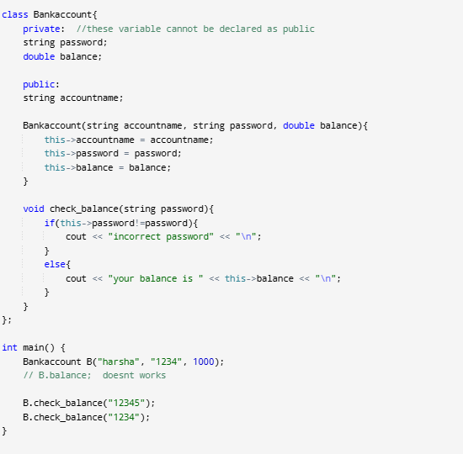
Output:
incorrect password
your balance is 1000

Abstraction:
Abstraction is hiding the complex internal implementation and only showing required information.
Lets take a coffee machine, the only thing we have to know is pressing the appropriate buttons for getting milk, coffee or stirring. We don’t need to know how the machine is working internally.
End users don’t need to keep extra efforts in understanding the controls when system gets updated.

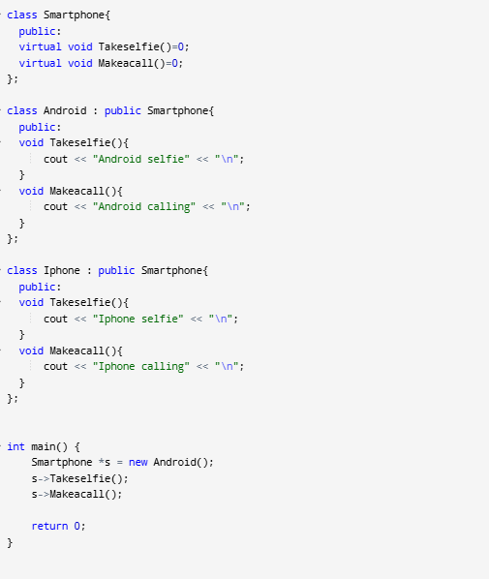

Data abstraction:
This type only shows the required information about the data
Example: Imagine a smartphone contact list.
You see names and phone numbers. You don’t see how the phone stores this information, like the database structure or file format.
Control abstraction:
This type only shows the required information about the implementation
Example: We don’t need to understand all the internal structure and working of coffee machine.
its enough to just know the controls.

Both encapsulation and abstraction may look same but not same:
Encapsulation : Data hiding of member variables (security)
Abstraction : hiding the complexity of the process.

Polymorphism:
Means having many forms.
Ex: A man can be a husband, father, son at same time.
a)compile time polymorphism:(static binding)
static binding/early binding: deciding which method to be called when there are multiple methods with same name is done during compile time itself.
Because here methods are definitely differ in parameters of the method.
a)method overloading
b)Operator overloading
c)Method overriding without virtual function
b)runtime polymorphism (dynamic binding)
Dynamic binding/late binding: deciding which method to be called when there are multiple methods with same name is done during runtime.
a)virtual function

Examples of static and dynamic binding:
Suppose I am a chef and have to cook in a restaurant. The recipee that have to be cooked is definitely from the menu card. So I already know what are the items required to make that recipee before even started cooking it. It is an example for static binding.
One day I participated in a competition called master chef. At that time new item is given to us as a task. So at the time of cooking I have to think what items to use. It is an example for dynamic binding.

Method overloading:
Defining multiple methods with the same name but difference in the number of arguments or the data type of arguments or ordering of arguments. (difference in signature)
return type, definition can be same or different.
Ex:
class Add {
public:
int add(int a,int b){
return (a + b);
}
int add(int a,int b,int c){
return (a + b + c);
}
};
Method overloading is not possible in:
1. Methods only differs in data type of return value.
char fun()
return 'a' ;
int fun()
return 10;
2. only difference is int[] and int* either in parameters or return value.

Operator overloading:
Here we are giving special meaning to an existing operator in C++ without changing its original meaning.
Ex: using + for complex numbers.

member functions have access to all private data member of their own instances as well as those of other instances of the same class.
Here we are writing a parameterized constructor. So default constructor is erased. So we should provide default value to real and imag as 0
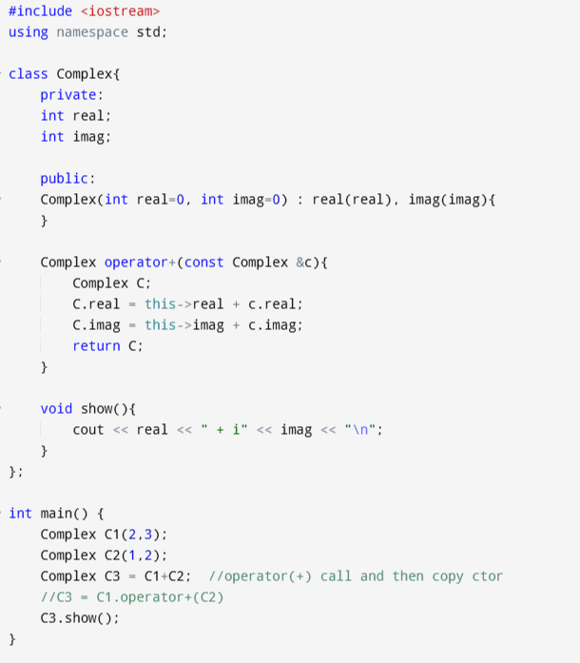

The only difference between operator function and normal function is
in operator function, the function name is operator keyword followed by symbol of operator.
Ex: operator+
When we write c1+c2, it will be called as
c1.operator+(c2)

Ex2: for assignment operator
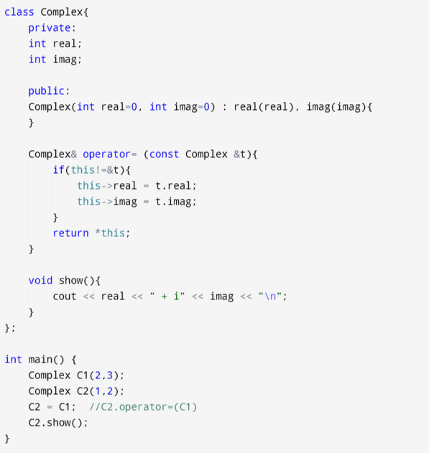

There is already a default assignment operator for classes.
As discussed in copy constructor, here also default assignment operator follows shallow copy and it will be problematic when object contains pointers to heap memory. In those cases we have to define our own assignment operator in which pointers (or references) of copied objects point to new copy of the dynamic resource allocated manually

What Overloading Means:
Overloading lets you change how an operator (like + or =) works for your own objects. You get to tell C++ what to do when you use that operator.
Why Overloading Works for Some Operators (Like = and +):
- These operators do simple things like adding or assigning values.
- For example:
  - + usually adds numbers (like 2 + 3 = 5).
  - You can teach it to add custom objects, like adding two Money objects to get a total amount.
- When you overload +, you’re not changing what + means—you’re just making it work with different types (like your custom object
- ts).
- The basic rule of adding things still stays the same.

Why Some Operators Can’t Be Overloaded (Like sizeof or ::):
- These operators are not about adding or assigning values—they control how C++ itself works.
- For example:
  - sizeof is used to find out how much memory something uses. It’s an inbuilt- feature that the compiler handles. Changing how this operators work would mess up C++’s internal rules
  - :: is used to specify where something is located (like choosing between two variables with the same name). It’s also an inbuilt feature that the compiler handles. Changing how this operators work would mess up C++’s internal rules
- Changing how these operators work would mess up C++’s internal rules, like how it handles memory or keeps track of where things are.

1. sizeof Operator:
- It gives the size of something (like a variable or data type) in memory.
- The compiler figures this out, not your code. Changing how this works would break important parts of C++, like how memory is handled.
2. Scope Resolution (::) Operator:
- It helps you access things like global variables, class members, or namespaces.
- It works with names (like a class or variable name), not values. C++ doesn’t have a way to let you change how it handles names.
3. Class Member Access Operators (. and .*):
- The . operator is used to access an object’s members (like variables or functions).
- Changing this would break how you normally use objects. For example, calling obj.function() would stop working the way it should.
4. Ternary (?:) Operator:
- It’s a shortcut for if-else, like:
- Only one option is supposed to run based on the condition. If you could change this, it might run both options, which would defeat its purpose.
5. typeid Operator:
- It tells you what type (like int, double, or a class) something is.
- Its job is to correctly identify types. If you could change this, it would mess up how C++ identifies types, leading to errors.

Try to see about conversion operator at last of operating overloading article

Method overriding Without virtual function:
redefining a base class function in derived class function with same return type and parametres. (same signature)

#include <iostream>
using namespace std;
class parent{
public:
void call()
{
cout << "parent was called";
}
};
class child: public parent
{
public:
void call()
{
cout << "child was called";
}
};
int main()
{
child P;
P.call();
return 0;
}
Output :
child was called

Call overridden function from derived class:
#include <iostream>
using namespace std;
class parent
{
public:
void call()
{
cout << "parent was called";
}
};
class child: public parent
{
public:
void call()
{
cout << "child was called" << "\n";
parent :: call();
}
};
int main()
{
child P;
P.call();
return 0;
}
Output:
child was called
Parent was called

#include <iostream>
using namespace std;
class parent
{
public:
void call()
{
cout << "parent was called";
}
};
class child: public parent
{
public:
void call()
{
cout << "child was called" << "\n";
}
};
int main()
{
child P;
P.call();
P.parent::call();
return 0;
}
Output:
child was called
Parent was called

class Animal {
public:
string color()
{
return "black";
}
};
class Dog : public Animal {
public:
string color()
{
return "grey";
}
};
int main(void)
{
Dog d;
Animal* a = &d;
cout << a->color();
}
Output: black
class Animal {
public:
string color = "Black";
};
class Dog : public Animal {
public:
string color = "Grey";
};
int main(void)
{
Dog d;
Animal* a = &d;
cout << a->color;
}
Output: black

Virtual function: (dynamic binding)
It comes under runtime polymorphism i.e deciding which method to be called when there are multiple methods with same name is done during runtime.
Because at runtime only, virtual pointers are generated along with the objects
A virtual function is used to replace the definition written in base class. Definition is replaced even when base pointer is pointed to derived class object.
Virtual keyword is added in base class function.
At run time, which function has to be called was decided based on type of object pointed by base class pointer.

#include <iostream>
using namespace std;
class base
{
public:
virtual void print()
{
cout << "print base class" << "\n";
}
void show()
{
cout << "show base class" << "\n";
}
};
class derived: public base
{
public:
void print()
{
cout << "print derived class" << "\n";
}
void show()
{
cout << "show derived class" << "\n";
}
};
int main()
{
derived D;
base *bptr;
bptr = &D;
bptr->print();
bptr->show();
return 0;
}
Output:
Print derived class
Show base class

Some rules:
1. Virtual functions cannot be static.
2. A class may have a virtual destructor but it cannot have a virtual constructor.
3. Virtual function can be a friend function of another class.
4. Function in base and derived class should have same return type and parameters.
5. It is not mandatory for the derived class to override (or re-define the virtual function). in that case, the base class version of the function is used.

Dynamic binding can extends upto multiple levels
#include <iostream>
using namespace std;
class Animal {
public:
virtual void speak() {
cout << "Animal makes a sound" << endl;
}
};

class Dog : public Animal {
public:
void speak() {
cout << "Dog barks" << endl;
}
};

class Cat : public Dog {
public:
void speak() {
cout << "Cat meows" << endl;
}
};

int main() {
Dog D;
Cat C;
Animal* animal1 = &D;
Animal* animal2 = &C;

animal1->speak();
animal2->speak();
return 0;
}
Output:
Dog barks
Car meows

Working of virtual function:
Virtual table:
During compilation, a virtual table is created for each class which contain virtual functions and classes that are derived from them. Because child generated from parent with virtual functions have got some virtual flavour.
Each virtual table of a class is a static array of function pointers. Its a static array i.e created during compile time.
Function pointers in each virtual table points to most recently overrided functions of virtual functions of base class and if there are no overrided function then they points to the virtual function.
Lets consider there is a virtual function in the base class and in between current class and base class there is a multilevel inheritance, then function pointers of current class check whether there is an overrided function of virtual function in current class and if it's not there then it will go for parent class and so on.
Virtual pointers:
During runtime, Each object of a class that contains virtual functions and classes derived from it, contain a virtual pointer along with member variables and methods. This virtual pointer of the created object points to the virtual table of the corresponding class.
So, when an object is created and some function is called, with the help of virtual pointer, virtual table can be accessed and with the help of virtual table required function can be called.
Virtual table - compile time
Virtual pointer - runtime

Ex: each employee have a common rise in salary but manager can have an extra rise compared to employee

class employee {
public:
virtual void raise salary(). -------> 1
virtual void promote(). --------> 2
};
class manager : public employee {
public:
void raise salary(). -------> 3
};

Virtual table of employee contains address of functions 1 and 2
Virtual table of manager contain address of functions 3 and 2

The major use of this virtual functions is dynamic dispatch or runtime polymorphism. Virtual functions enable the method calls to be decided at runtime based on the actual type of the object, which method overriding (without virtual functions) cannot do if you're working with pointers or references to the base class.
Ex: There is a payment class(base class which contains virtual function) and
(creditPayment class, UPIPayment class) both are derived from payment class
By just using Payment class pointer we can refer the methods inside creditPayment and UPIPayment classes

Limitations of Virtual Functions
- Slower: The function call takes slightly longer due to the virtual mechanism and makes it more difficult for the compiler to optimize because it does not know exactly which function is going to be called at compile time.
- Difficult to Debug: In a complex system, virtual functions can make it a little more difficult to figure out where a function is being called from.

Pure virtual functions:
A pure virtual function is a virtual function for which there is no definition wrt base class.
We place =0; in the declaration
Ex:
Class base{
public:
virtual void draw() = 0;
} ;
Class derived : public base
{
public:
void draw()
{
cout << "rectangle";
}
};
int main()
{
derived D;
base *bptr;
bptr = &D;
bptr->draw;
}

Abstract class:
Class which contains atleast 1 pure virtual function.

#include <iostream>
using namespace std;
class animal {
public:
virtual void sounds()=0;
};
class dog : public animal{
public:
void sounds()
{
cout << "bowbow" << "\n";
}
};
class cat : public animal
{
public:
void sounds()
{
cout << "meow meow" << "\n";
}
};
int main()
{
cat C;
dog D;
animal* x1 = &C;
animal* x2 = &D;
x1->sounds();
x2->sounds();
}
Output :
meow meow
bowbow

Important points regarding abstract class:
1.We cannot create objects for abstract classes.
2. If we do not override the pure virtual function in the derived class, then the derived class also becomes an abstract class.

#include <iostream>
using namespace std;
class Base {
public:
virtual void show() = 0;
};
class Derived : public Base {
};
int main(void)
{
Derived d;
return 0;
}
Output:
Compilation error.

//A point regarding constructor is pending

